

Newsletter



Jan-June 2021

## Department of

**electrical and electronics engineering**

# Editorial Message

###### “No resistance can drop our potential”

*Heartily welcome to the* ***6th Edition*** *of our Departmental Newsletter.*

*We are very delighted and proud in presenting this newsletter to showcase the latest developments and programs which happened in our department.*

*It is indeed a great pleasure to note that our Department is publishing the newsletter on half yearly basis on every aspect of activities and events held during the semester. The newsletter aims to bring into view various proceedings, functions, events, news, accomplishments and happenings in the Department.*

*News letter acts as a communication channel among the alumni, faculty, students and experts in Electrical and Electronics Engineering.*

*We are very much grateful to the Management, Rector and Principal for their continuous encouragement, inspiration and support extended for the release of this “NEWS LETTER”*

***Editorial Board Members:*** *Mr. Manu Pandey (8th Sem) Monal Panjwani (6th Sem) Prof. Aamir Nasir*

*Assistant Professor EX Dept. SISTec Bhopal*

*Prof. Ankit Chourasia*

*Assistant Professor EX Dept. SISTec Bhopal*

*Prof. Sitaram Raikwar*

*Assistant Professor EX Dept. SISTec Bhopal*

***Editor in Chief:***

*Dr. Ashish Kumar Rai*

*Associate Professor & HOD EX Dept. SISTec Bhopal*

***Advisory Board:***

*Dr. Keshavendra Choudhary*

*Principal SISTec Gandhinagar, Bhopal*

*Dr. Swati Saxena*

*Vice-Principal SISTec Gandhinagar, Bhopal*

2

# Vision, Mission & PEOs of Electrical and Electronics Engineering Department

### Vision:

To impart technical education theoretically and practically to set global standards, making the students technologically superior, to face the technological challenges.

### Mission:

* + - To educate the students with the state of the art technologies in the field of Electrical and Electronics Engineering to cope up the growing industrial challenges.
    - To prepare professionals with good technical skills who can contribute in research and innovation for the well being of the society and the country.
    - To develop professional competency among the students, for achieving success in career, higher education and self-employability.
    - To inculcate awareness, responsibility and ethical attitude for overall professional development.

### PEOs:

**PEO1:** Produce engineering graduates having strong foundation in mathematics, science, management and core electrical engineering in order to develop seamless knowledge for providing solution to engineering problems.

**PEO2:** Provide competent learning environment and develop entrepreneurship capabilities in the field of Electrical and Electronics Engineering with skill, creativity and innovation.

**PEO3:** Create high standards of ethical values and inculcate research capabilities among the graduates to help industry and society as a whole.*.*

3

**List of Contents**

|  |  |  |
| --- | --- | --- |
| **Sr.**  **No.** | **Content** | **Page No.** |
| 1 | **(A) Departmental Activities** |  |
| 2 | I. NAAC Accreditation |  |
| 3 | II. Establishment of Electric Vehicle Lab |  |
| 4 | III. Mr. Murli Manohar, Assistant Professor, EX -department, successfully defended his PH.D Thesis. |  |
| 5 | IV. PH.D awarded to Dr. Ashish Kumar Rai, H.O.D., EX |  |
| 6 | **(B) Student Activities** |  |
| 7 | I. SAC Interviews |  |
| 8 | II. Virtual Farewell event |  |
| 9 | **(C) Achievement & Awards** |  |
| 10 | **(D) Placement** |  |

NAAC Accreditation



Sagar Institute of Science and Technology [SISTec](https://www.facebook.com/hashtag/sistec?__eep__=6&__cft__%5b0%5d=AZUmxZqgmBN0SW-FNi3Avaf7uP_yd-PaG3Hd6szCLC74CXla3zbRWMyTqajZPKf4649_9L2oZLLYMwahpe3k8j0Z1jdLG4KmLehT-GOv76DCAgnelPKi-0p74SFlkj7sdIg&__tn__=*NK-R), Congratulates all the stakeholders for getting distinguished accreditation by the *National Assessment and Accreditation Council ( NAAC).* With the benevolence of the management, foresighted administration, and staff along with the avid students, it was possible to gain this feat. This accreditation is a certification affirming the quality of education imparted at [SISTec](https://www.facebook.com/hashtag/sistec?__eep__=6&__cft__%5b0%5d=AZUmxZqgmBN0SW-FNi3Avaf7uP_yd-PaG3Hd6szCLC74CXla3zbRWMyTqajZPKf4649_9L2oZLLYMwahpe3k8j0Z1jdLG4KmLehT-GOv76DCAgnelPKi-0p74SFlkj7sdIg&__tn__=*NK-R).

Establishment of Electric Vehicle Lab

The Electrical & Electronics Department established an Electrical Vehicle lab in Feb-2021 for the purpose of retrofitting of old 2-wheeler into an electric vehicle.

Mr. Murli Manohar, Assistant Professor, EX -department, successfully defended his PH.D

Mr. Murli Manohar, Assistant Professor, EX -department, successfully defended his PH.D Thesis on the topic “*Enhancing the reliability of micro grids using machine learning based protection techniques*.” on 22/APRIL/2021.A person sitting at a desk with a computer

**PH.D awarded to Dr. Ashish Kumar Rai, H.O.D., EX**

Dr. Ashish Kumar Rai, HOD, got his Ph.d degree completed successfully. His Ph.d topic was *“Performance Analysis Of Super Critical Power Plant using Imported Coal And Enhancement of Plant Availability by Retrofitting of Pulverizer*” from R.G.P.V. in Feb 2021.

**SAC Interviews**

Interviews were held for the upcoming session for the formation of SAC committee in Jan-2021. The students appeared for various positions like Hostel and Mess Committee, Sports Committee, Academic Affairs Committee, Cultural Committee, IT Committee, Alumni Committee, Editorial Committee

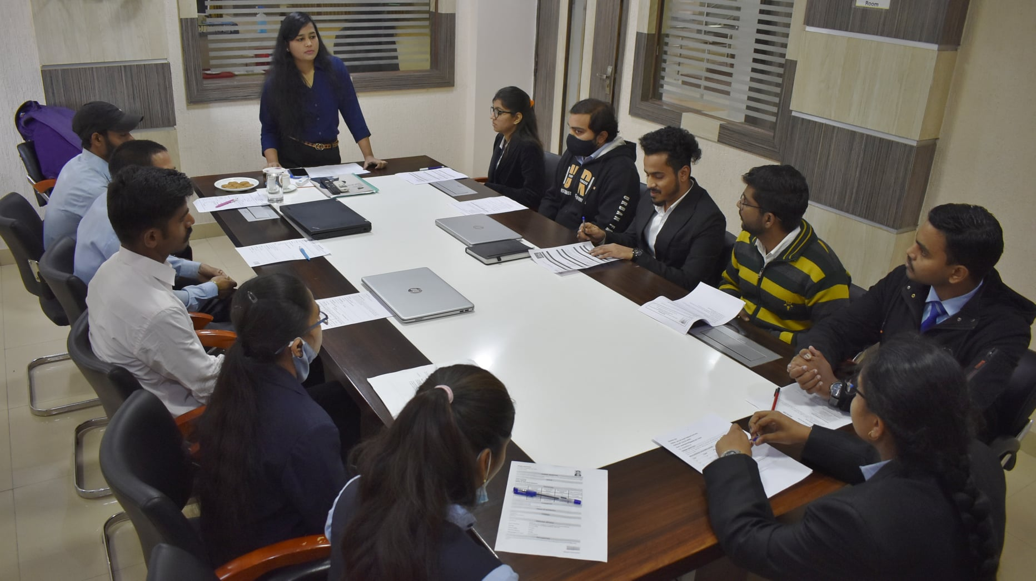

**Virtual Farewell event**

A virtual farewell event was conducted on Google Event during the pandemic of 2021 by the batch-2018 for their seniors in May 2021. An online meetup took place in which senior and junior students interacted from their homes.

**PLACEMENTS**

